Old Doune Road Nursery – Snack and meal menu
WEEK 1
DAY | MORNING SNACK | LUNCH | AFTERNOON SNACK
Monday | Ricecakes | Macaroni cheese with peas and sweet corn  Yoghurt and fruit | Vegetable fajitas (peppers, onions, tomatoes and seasoning)  Wheat
Tuesday | Fruit salad with natural yoghurt dipping  Milk | Chicken and vegetable curry with boiled rice  Jelly and fruit | Minestrone Soup (onion, carrots, celery, broken spaghetti, runner beans, chopped tomato and veg stock)  (1/2 slice white bread)  Milk, celery, wheat
Wednesday | Black pepper thins with tzatziki dip  Wheat, Barley, Milk | Pea soup with wholemeal bread  Rice Pudding | Chunky Vegetable Pasta  Wheat
Thursday | Crumpets  Wheat | Bangers and mash with mixed vegetables  Yoghurt and fruit | Filled pitta pocket (tuna)  Fish, wheat
Friday | Rice crispies  Milk, barley | White fish with tomato pasta  Flapjacks | Toast and beans  (Wholemeal Bread)  Wheat
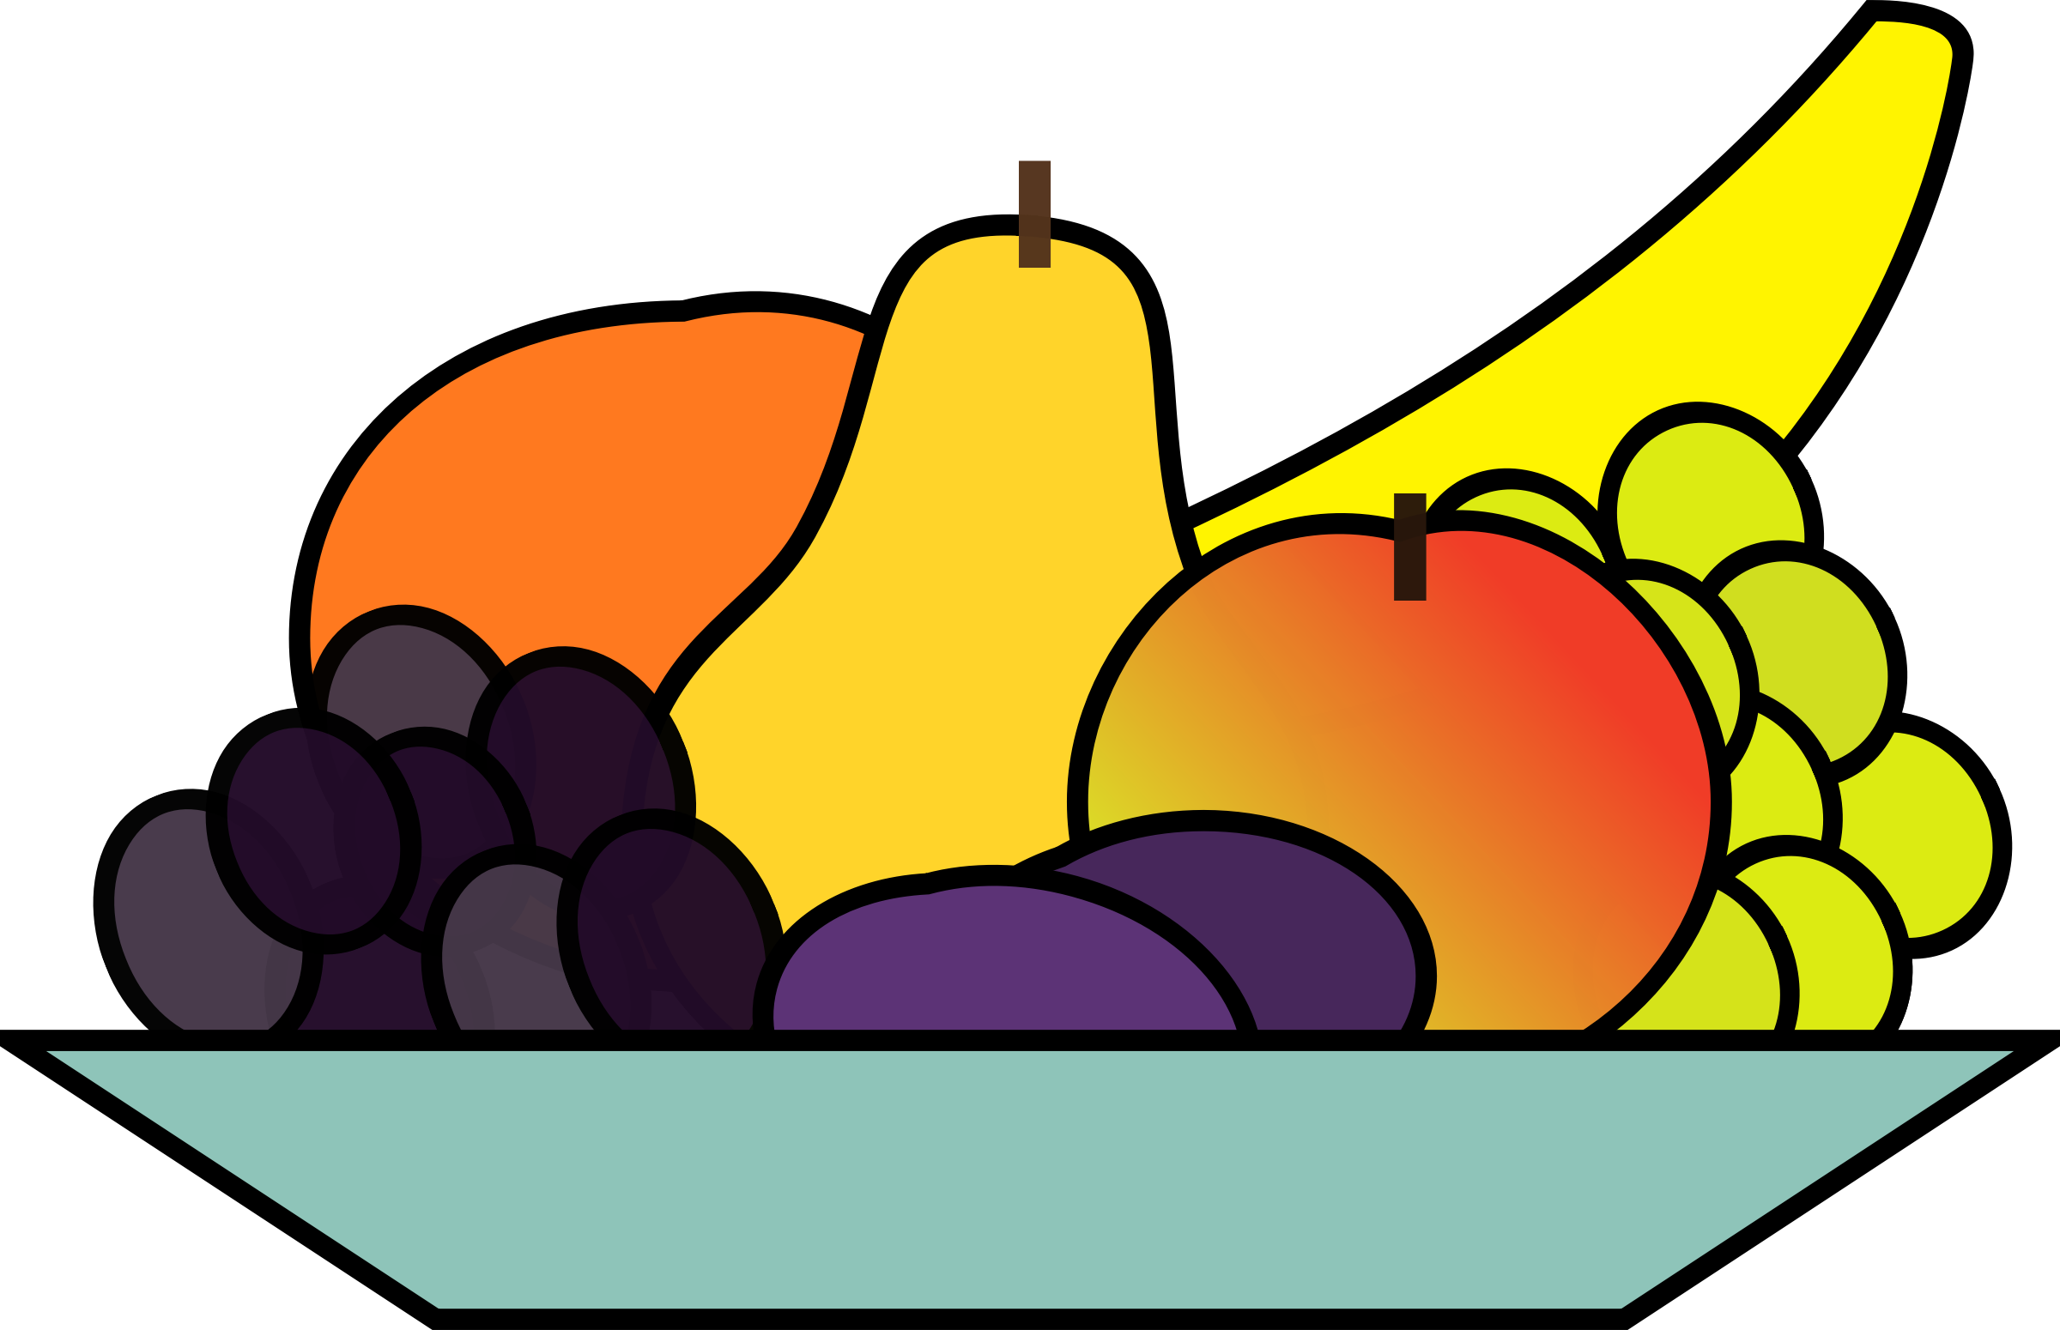
Morning and afternoon snack come with fresh fruit or vegetables
Snacks may change day due to expiry dates of food delivered

