Old Doune Road Nursery – Snack and meal menu
Week 2
DAY | MORNING SNACK | LUNCH | AFTERNOON SNACK
Monday | Weetabix  Wheat, milk | Rice with chicken and mushroom  Yoghurt and fruit | French bread with soft cheese  Wheat, milk
Tuesday | Ryvita crackers | Lentil soup with wholemeal bread  Rice pudding | Chow mien  (noodle, grated carrots, spring onions, green beans with soy sauce and squeezed lemon juice)  Wheat, Egg
Wednesday | Fruit Salad | Tomato and tuna pasta  Fruit salad | Cheese and Tomato paninis  Milk, wheat
Thursday | Cream crackers  Wheat | Carrot and coriander soup with wholemeal bread  Banana cake | Salmon Sandwich (mixed with mayonnaise)  (White Bread)  Fish, Egg, Milk
Friday | Toast and Soft cheese  (Wholemeal)  Wheat, milk | Haggis and tatties  Yoghurt and fruit | Macaroni Cheese  Wheat, dairy, milk
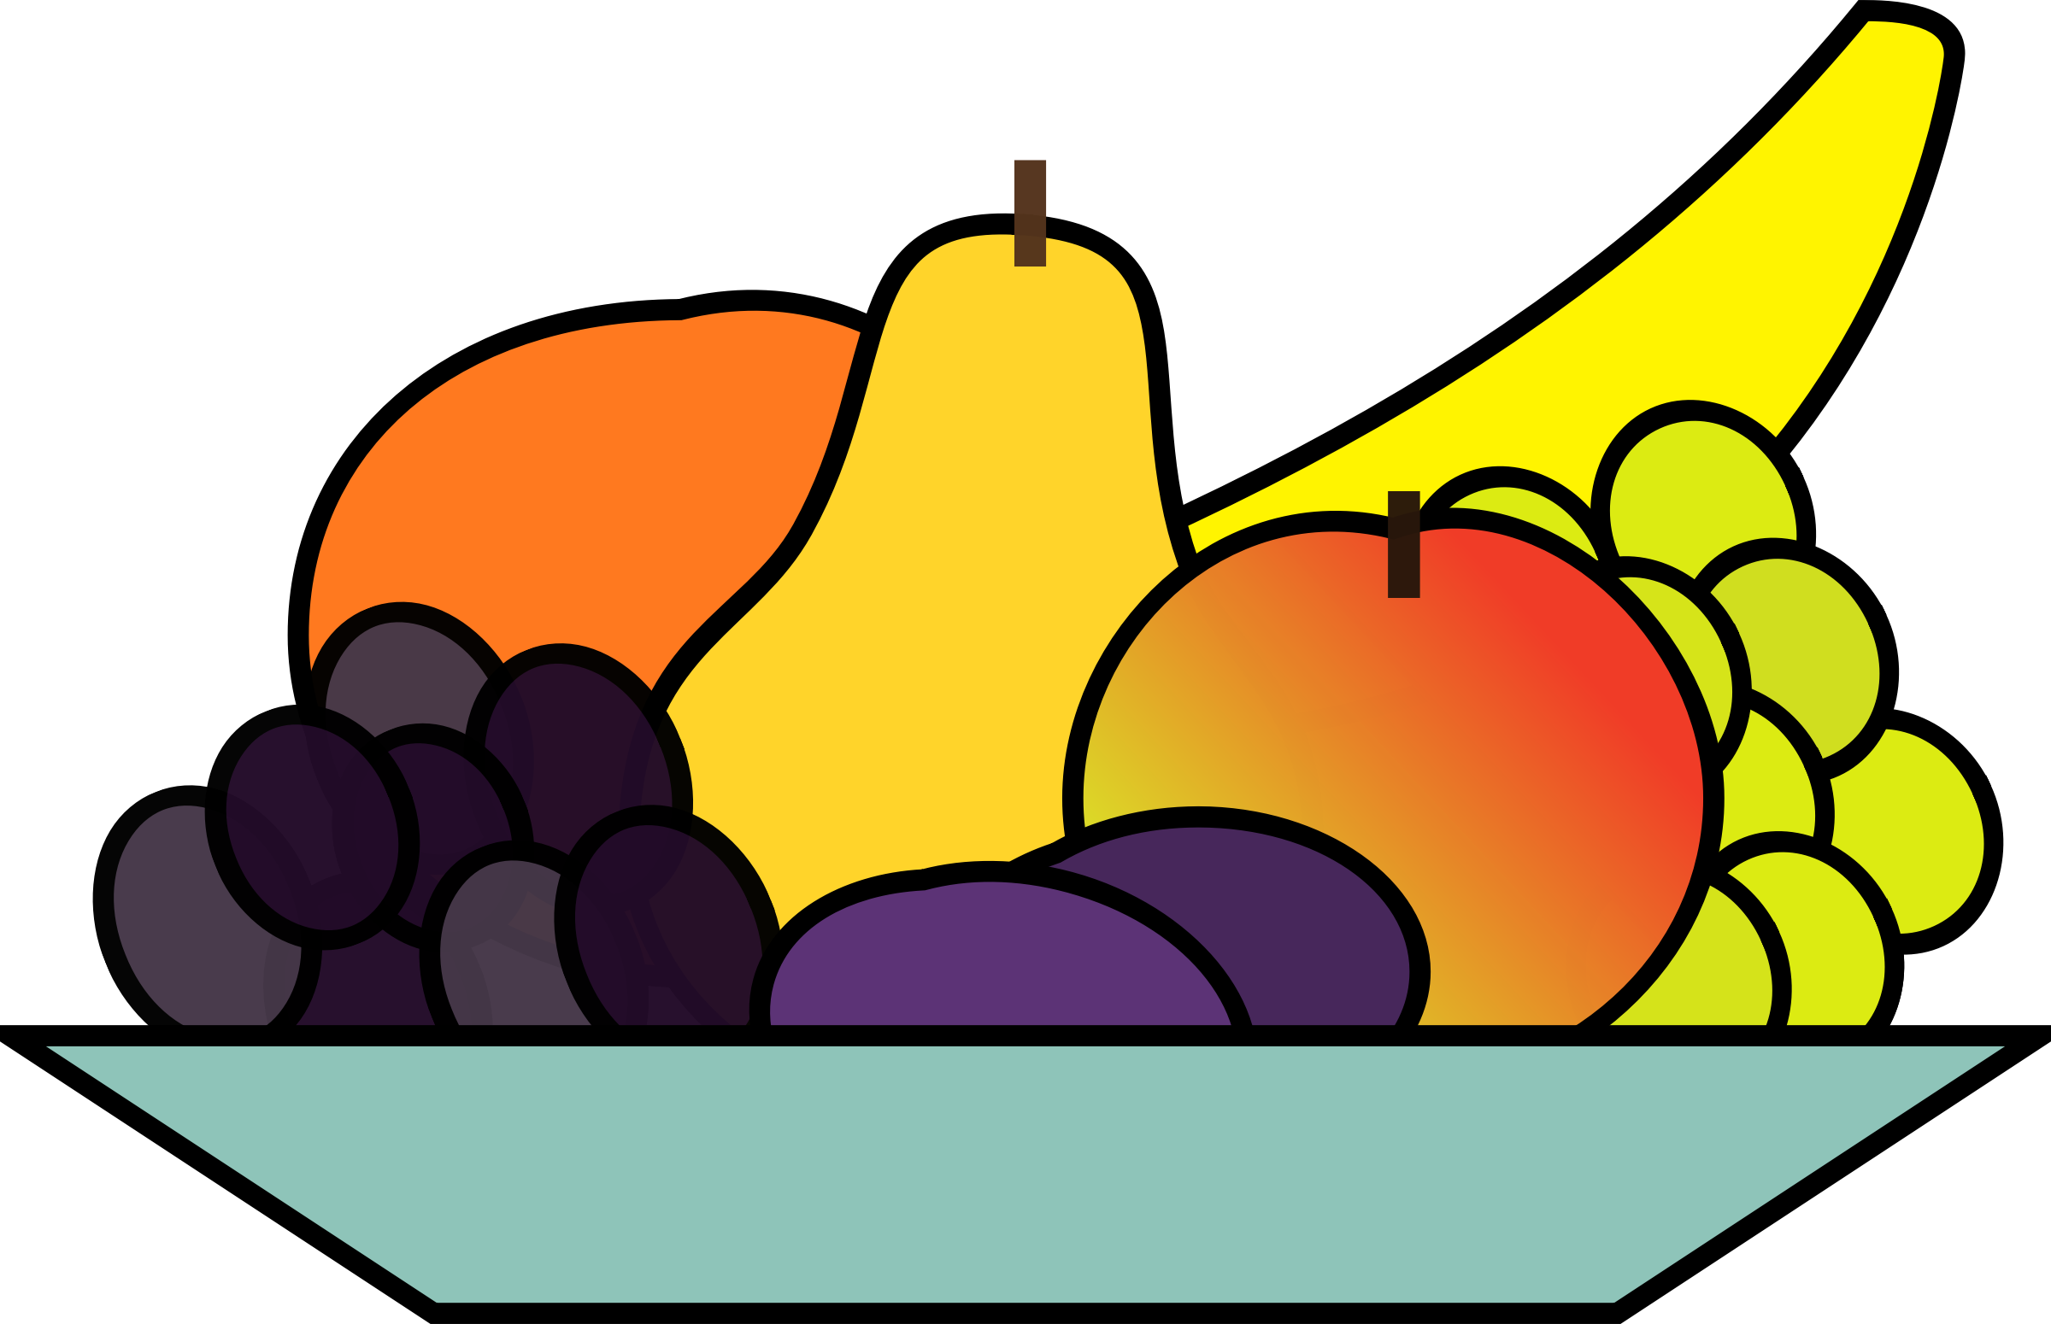
Morning and afternoon snack come with fresh fruit or vegetables
Snacks may change day due to expiry dates of food delivered

